**2025 *Pilgrims of Hope* Jubilee Year Mini-Grant Application Form**

**Catholic Campaign for Human Development Local Grants - St. Louis**

**Submit Application via Email to:** Marie Kenyon

Diocesan Director, Catholic Campaign for Human Development

(314) 792 - 7062

[mariekenyon@archstl.org](mailto:mariekenyon@archstl.org)

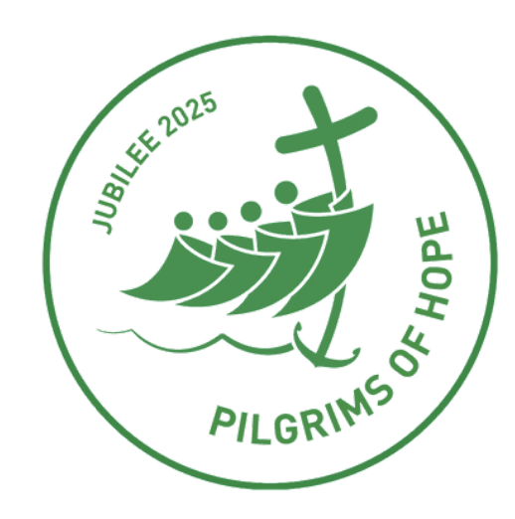

**Purpose:** As we celebrate the 2025 Jubilee Year, these funds will be used for projects that highlight the message and themes of this year’s jubilee theme, “Pilgrims of Hope” with a specific emphasis on reaching out to those on the margins at the parish and community level. Funds are to be used for general operating support for applications that may include bringing a speaker to your parish, trainings, events, webinars, community activities, or other proposals.

**Grant Range:** up to $2,000

**Contacts:** Marie Kenyon, (314) 792-7062, [mariekenyon@archstl.org](mailto:mariekenyon@archstl.org) and Emily Alvarado, [emily.alvarado@slu.edu](mailto:emily.alvarado@slu.edu)

**Application Timeline:**

* Applications are available December 15th.
* Deadline for application is January 31st. Applications received after the deadline will not be considered.
* Grantees are responsible to obtain the endorsement of their local Pastor of the Catholic Church in their community.
* Grants are awarded in March 2025.

*Direct all questions or inquiries regarding grant eligibility to the contact persons listed above.*

**2025 *Pilgrims of Hope* Jubilee Year Mini-Grant Application Form**

**Catholic Campaign for Human Development Local Grants - St. Louis**

| **Grant Applicant Contact Information** |
| --- |
| **Contact Person:** |
| **Title of Contact Person:** |
| **Mailing Address:** |
| **E-mail:** |
| **Phone Number:** |
| **Parish/Organization Name: (If a particular ministry of the parish, please list the parish and the ministry)** |
| **Project Description** |
| **Project Name:** |
| **Project Description:** |
|  |

| **How will your project highlight the messages and themes of the Jubilee Year, *Pilgrims of Hope*?** |
| --- |
|  |
| **Amount of Funding Sought (*Maximum amount: $2,000):*** |
| **Basic Budget Breakdown *(Please detail how the funds requested will be used)*** |
|  |
| **Endorsement of Application by Pastor** |
| **Grant Applicant -** Please contact your parish’s pastor for approval and endorsement.  **Pastor** – The CCHD Advisory Committee is asking pastors to approve and endorse any of their parishioners’ applications for the 2025 *Pilgrims of Hope* Jubilee Year Mini Grants. To review grant guidelines, please see the grant overview section. If you have any questions, please refer to the contact persons listed on the first page. Thank you for your support. |
| **Parish:** |
| **Vicariate: ▢** Northern **▢** Southern **▢** Western |
| **Pastor Approval (Required): ▢** Yes **▢** No |
| **Pastor’s Name:** |
| **Pastor’s Signature of Endorsement:** |
| **Date:** |